

NATIONAL CYBER EMERGENCY RESPONSE TEAM
DEPLOYMENT REPORT

Name | Abdul Rehman
Assignment | 01
Date | 02/07/2026

SOFTWARE REQUIREMENTS:
- Oracle VirtualBox
- Ubuntu 24.10 Desktop (Operating System Running on Virtual Box)
- Internet Connection
- Nginx (Latest Version)

- Screenshots

  - Ubuntu Desktop:
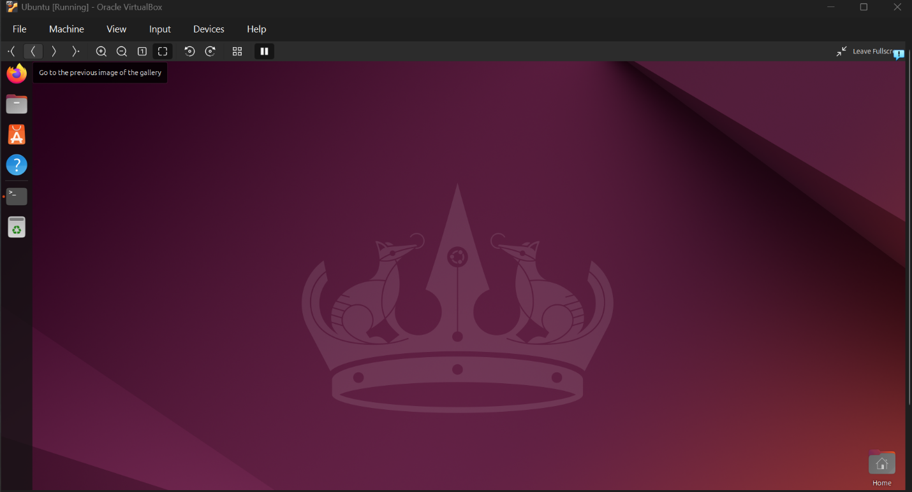
The screenshot shows that Ubuntu 24.10 is successfully installed on Virtual Box.

  - Nginx Installation:
The screenshot shows that Nginx is installed and it version is also shown.
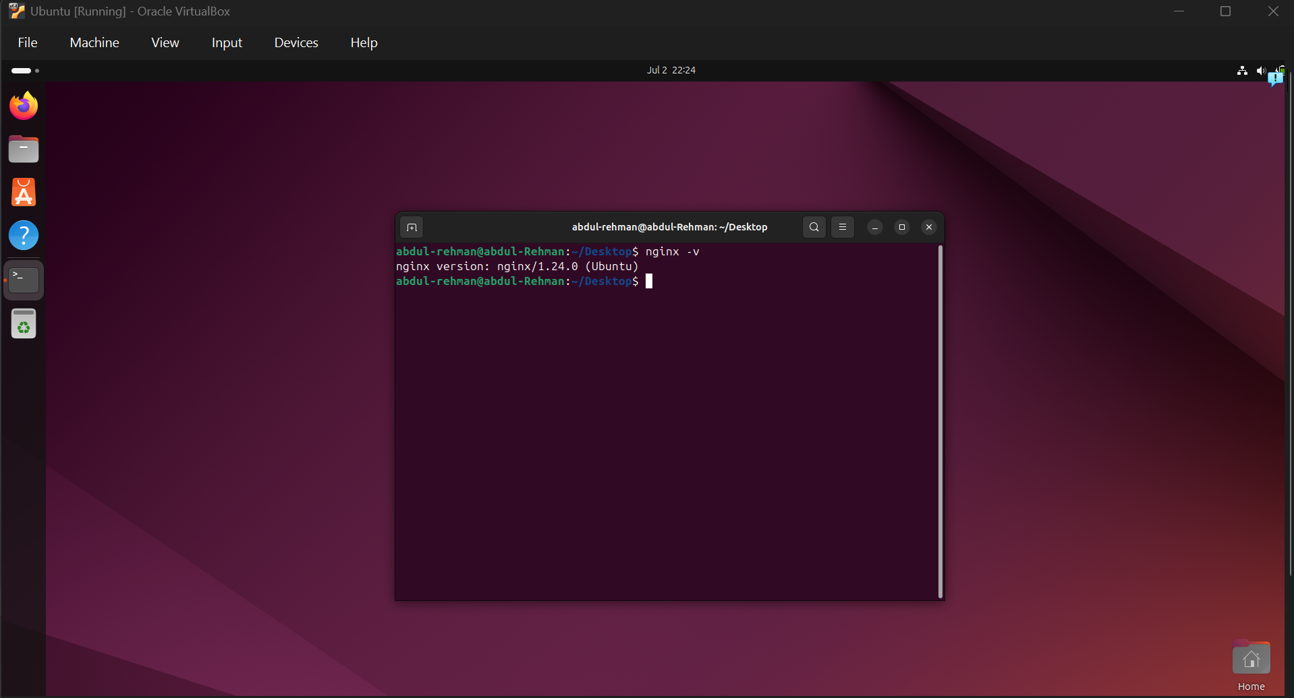

  - Website Running Successfully on PORT 8080:
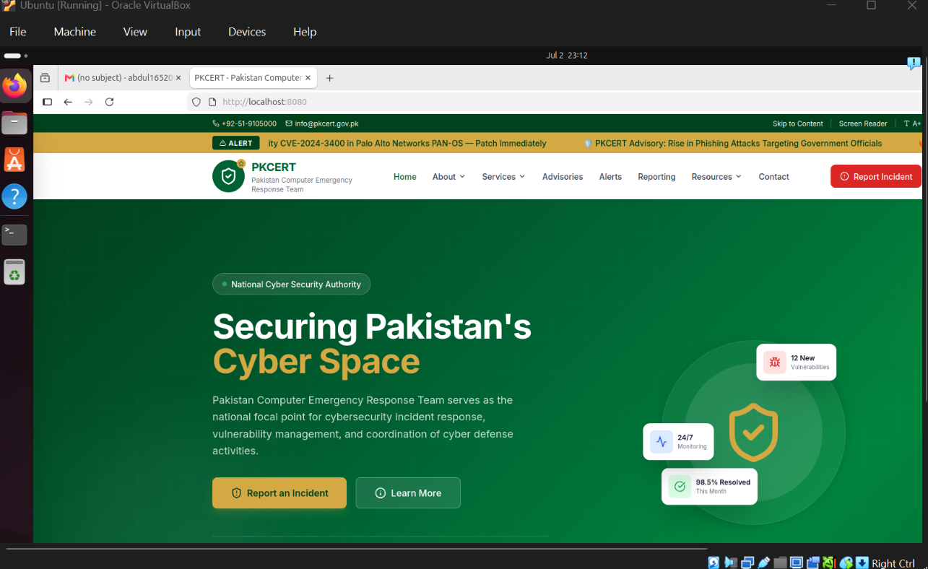
The screenshot shows NCERT landing Page Successfully running on Local Host 8080.

2.Learning, Challenges, and Solutions

Learning
- Learned how to create and configure an Ubuntu virtual machine in VirtualBox.
- Learned to install the Nginx web server using commands like sudo apt install nginx -y and verify it using sudo systemctl status nginx.
- Learned how to edit the Nginx configuration to change the server port from 80 to 8080 and host a custom HTML webpage.
- Improved my understanding of basic Linux terminal commands and file management.

Challenges
- Faced black and white screen issues after installing Ubuntu due to VirtualBox graphics settings.
- Initially found it difficult to configure Nginx and understand Linux terminal commands.
- Encountered file path errors while copying the HTML file to the Nginx web directory.

Solutions
- Fixed the graphics issue by selecting VMSVGA and disabling 3D Acceleration in VirtualBox.
- Used sudo nginx -t to verify the Nginx configuration before restarting the service, which helped identify configuration errors.
- Used the correct file path with the cp command and reloaded Nginx successfully to display the custom website.

